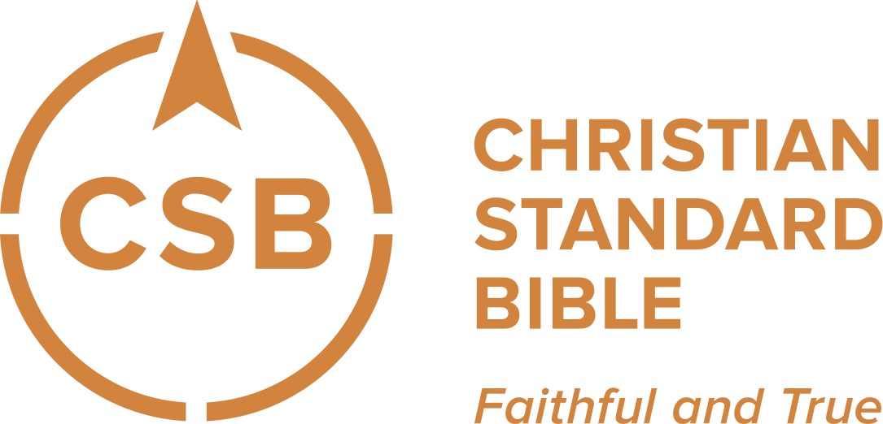

Registration for Ministry Grid
and Christian Standard Bible(CSB) Quiz

Below you will find instructions on how to access Ministry Grid and the Christian Standard Bible (CSB) retail associate quiz using a membership code.

For new Ministry Grid users:
1 – Go to www.ministrygrid.com and select “Sign Up” (If you already have a Ministry Grid account, see instructions for current users below.)
2 – Fill out the appropriate fields in the form. Your password must have least 7 characters and 1 number. Do not use special characters (i.e. - @ $ &).
3 – At the bottom of the form, enter the following membership code: VHU4HM (case sensitive).

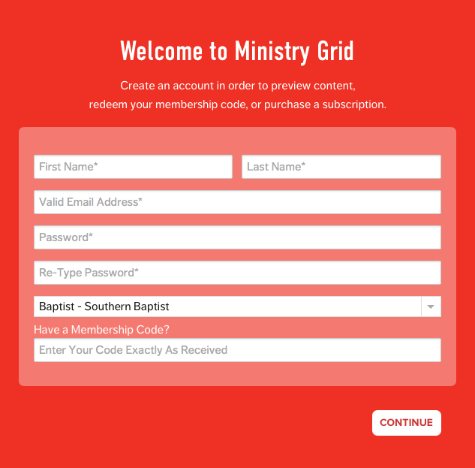

4 – Select “Continue” and wait as Ministry Grid registers you as a user and assigns you the CSB quiz to complete.

For current Ministry Grid users:
1 – Log in to your account.
2 – Insert the following membership code VHU4HM (case sensitive) in the prompt highlighted below.

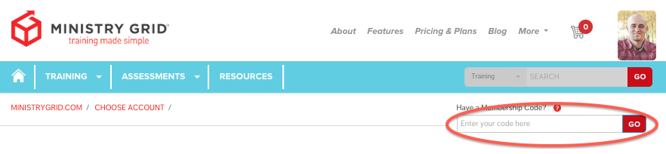

3 – Select “Go” and wait as Ministry Grid assigns you the CSB quiz to complete.

